Rock, Paper, Scissors
Rock Paper Scissors is a hand game where you have 3 common objects; Rock, Paper and Scissors. You both choose one of the objects at the same time; if you both choose the same object then it is a draw. Otherwise the following winning rules apply.
- Rock beats Scissors
- Scissors beat Paper
- Paper beats Rock
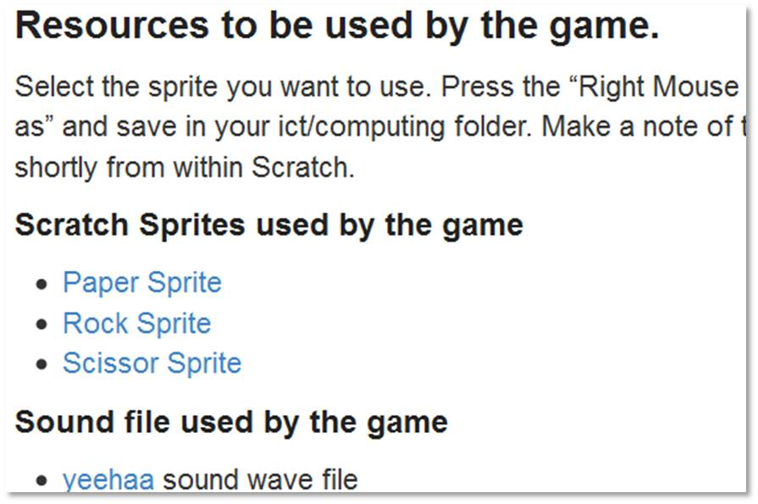
- Scoring only happens on winning moves.

Download to your documents ICT/Computing area the 3 sprites, by selecting the hyperlink, pressing right mouse button and selecting “save target as”
- Rock.sprite
- Paper.sprite
- Scissor.sprite

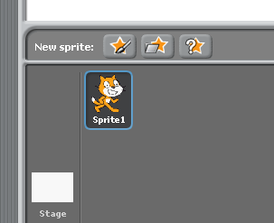
Select the “choose new sprite from file” button.

Find you way to the folder where the recently downloaded sprites are located.

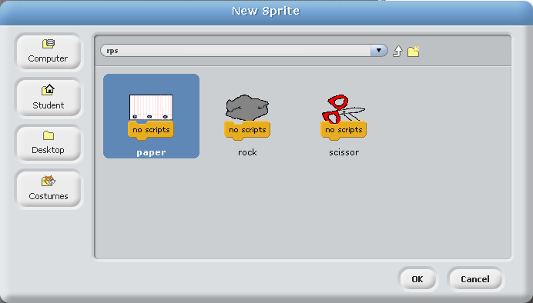
Now select the 3 sprites one at a time and load into Scratch.

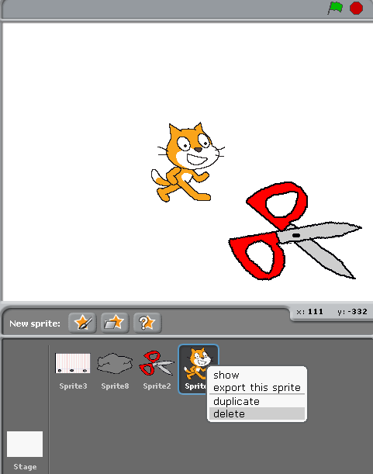

Now we need to get rid of the Cat Sprite

So select the cat sprite, press right mouse button and select delete

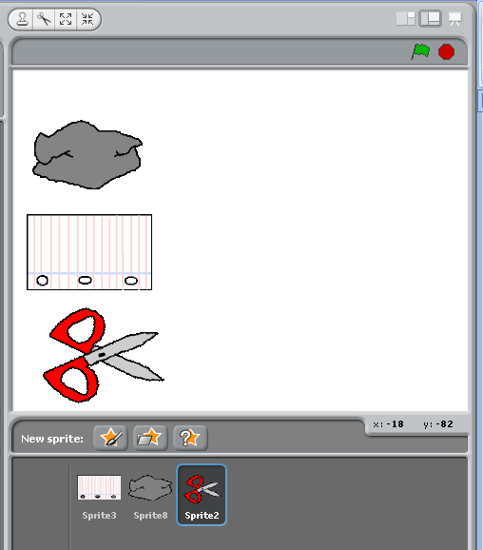
Arrange the rock, paper and scissor sprites as a column something like this, you as the human player will play with these sprites on the left hand side.

You may need to resize the sprites using one of these two button s

Duplicate these sprites by pressing the right mouse button and selecting ‘duplicate’
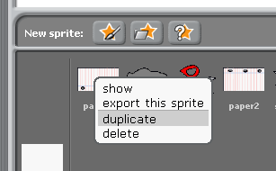

Then arrange the sprites so that you have two columns of rock paper scissors. The computer will use the ones on the left.
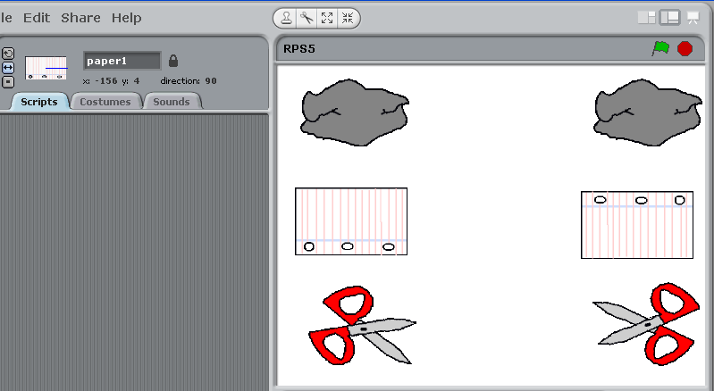
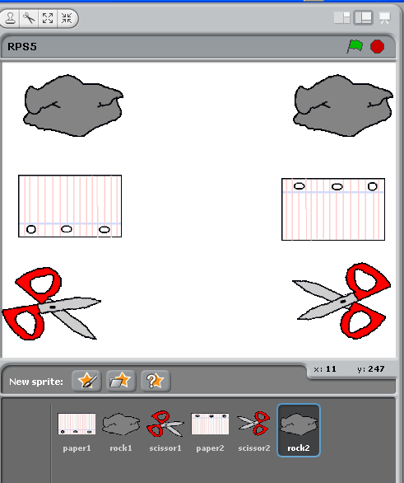
Change the names of the sprites so that the ones on the left are called rock1, paper1 and scissor1. Change the ones on the right to rock2, paper2 and scissor2.

Also you can rotate the sprites by using this button.

So it should look something like this.

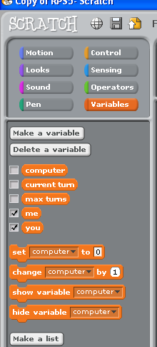
This game will use many variables, so let’s define the variables that we need.

Press the variables button
Then press “make a variable” for each of the following:-
- ‘me’ this will hold the score for how many rounds the computer has won.
- ‘you’ this will hold the score for how many rounds that you as the human has won.
- ‘max turns’ how many rounds you want the game to last.
- ‘current turn’ what is the current turn number (round) that we are playing.
- ‘computer’ this is a slightly more tricky one to grasp. Each turn will we use a random number to determine which of the three sprites the computer is going to select. What the computer selects will be held in this variable. The values it can be are
  - 1 = rock
  - 2 = paper
  - 3 = scissor

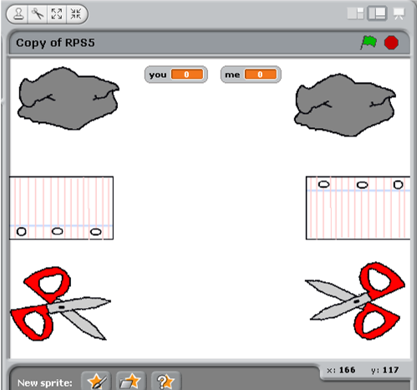
For the six sprites on the screen we need to tell them where their starting positions are.

So for each sprite put the mouse in the centre of the sprite and note the x and y co-ordinates at the bottom right

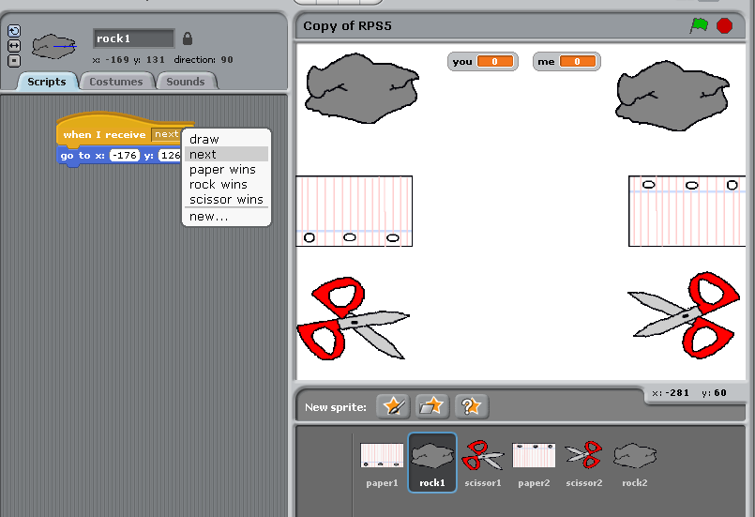
So in this example for Sprite “rock1” (the rock in the top left).

Select “When I receive” from control, select “next” from the “when I receive” drop down box.

If “next” does not exist then select new and create a “next”

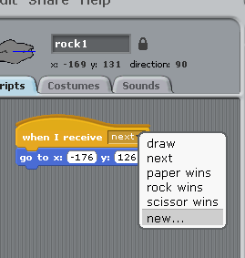

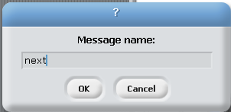
Next select “go to x: y:” from motion. Put in the x and y co-ordinates of this sprites starting position that you noted earlier.

So repeat this for all six sprites

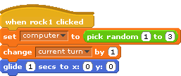
Add this script to ‘Rock1’. So this says that when “rock1” is clicked that we select the computers playing piece by using a random number, add one to the current turn. Then glide to the centre of the screen (hopefully the computers selected piece will also glide to the centre of the screen, so we can use a “touching” command to see what’s happened.)

Repeat this script for ‘Paper1’ and also ‘Scissor1’. (obviously the when ? clicked name will changed).

Now let’s start the scripts for the computers sprites (which are rock2, paper2 and scissor2)
Below is the script for the computers rock sprite (rock2)

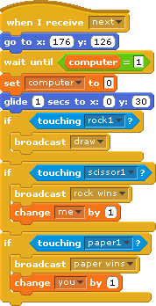
You should already have the first two commands from earlier on

This says wait until rock has been selected for the computer (see top of page 4)
Reset the variable “computer” back to its starting value and move to the centre

Now we have a look and see what the result is, remember we are the computer (rock2), so we broadcast a result based on what we are touching in the centre of the animation screen. There are only 3 outcomes (from the rocks point of view)

We also increase the counters which keep the score for the computer (me) or the human (you).

As before with the receive command (page 4) you may need to create a new broadcast message (if it’s not already there).

So now you need to write the script for “Paper2” sprite. When you write this script it should only react when the variable computer=2. Also bear in mind the broadcast messages will be slightly different from rock2 as it is paper this time.

Finally you need to write the script for “Scissor2” sprite. When you write this script it should only react when the variable computer=3. Also bear in mind the broadcast messages will be slightly different from rock2 as it is scissor this time.

Ok we have the playing sprites with their scripts attached to them. So now we need some method of controlling what moves when and showing the person playing the game who won what round.

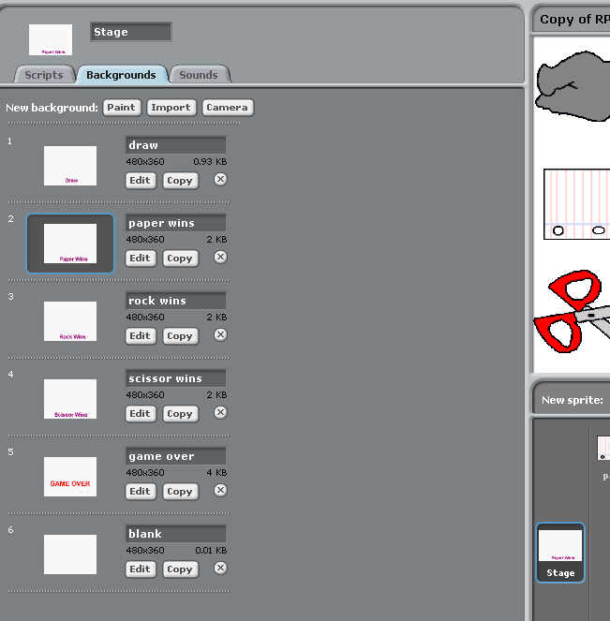
Make sure that the stage is selected
Select the Backgrounds tab

We need to make 6 backgrounds for the stage these are
- Draw
- Paper wins
- Rock wins
- Scissor wins
- Game Over
- Blank

Below are a couple of examples of the screens I used

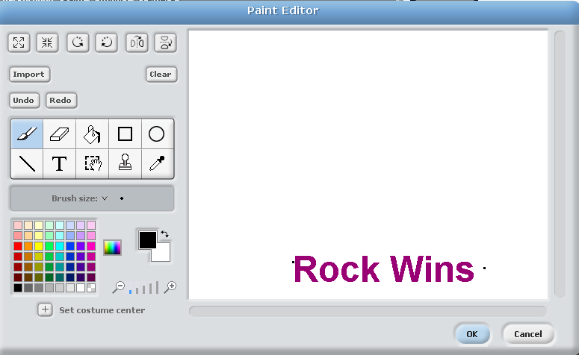
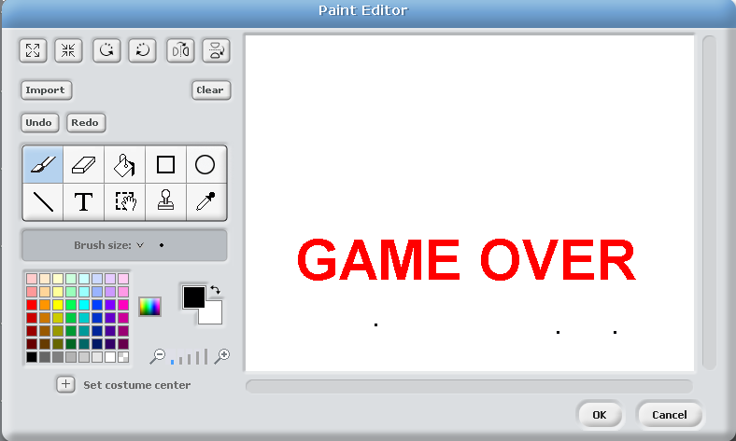

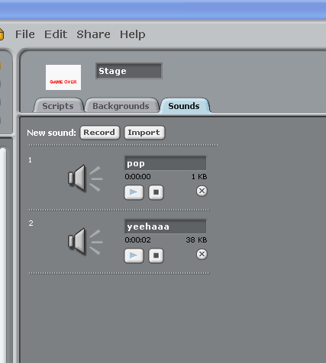
Select the “Sounds” tab and import a couple of sounds that you would like to use (note yeehaaa can be found on the Scratch intranet site)

Make sure you are in the script area for the Stage.
Below is the script that needs to run when scissor wins that round
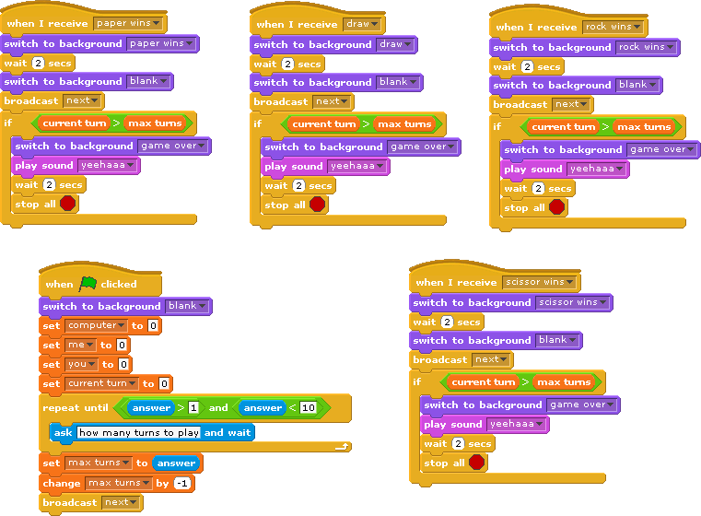
We change the background to show the text “scissor wins” for 2 seconds
And then set it back to blank

Broadcast next (which is basically the signal for next turn)

Have we now finished?
If so display a message play a sound and stop all scripts

You now need to create the scripts for
- Rock wins
- Paper wins
- Draw
These should be based upon the script for “scissor wins” above

Lastly we need to create the start up script for this game (still in the script area for stage)

So here we set a blank background

Set numerous variables to zero

Ask the user how many turns they want to play

Then broadcast the next message (i.e. next game turn)

So that’s all there is to it.

